Logic Programming and Prolog

Logic programming refers to a family of languages and an associated programming style based on writing programs as a set of assertions (facts and inference rules). The execution of a logic program is a kind of deduction on the specified facts and inference rules. Prolog is such a logic programming language.

1) A Prolog program

A PROLOG program consists of facts for describing object features or relationships, and rules for inferring new properties and relationships from other properties and relationships.

For instance: female(pam) expresses the fact that pam is a female

parent(pam, bob) expresses the fact that pam is a parent of bob

A rule has the following form: X :- Y1, Y2, ... ,Yn

which may be read as "X is true if Y1 is true and Y2 is true and ... and Yn is true"

X represents the head of the rule and Y1, Y2, ... ,Yn represents the body.

":-" is read "if"

For instance: mother(X, Y) :- parent(X, Y), female(X)

means X is mother of Y if X is parent of Y and X is a female.

Generally, Prolog facts and rules are Horn clauses.

A Horn clause is a clause with at most one positive literal (or a clause with at most one atom in the left hand side of :-.

Example

The following is an example of a Prolog program, about a particular extended family

parent(pam, bob). % Pam is a parent of Bob

parent(tom, bob). % Notice that in Prolog the constants

parent(tom, liz). % are written in lower case

parent(bob, ann).

parent(bob, pat).

parent(pat, jim).

female(pam). % Pam is a female

male(tom). % Tom is a male

male(bob).

female(liz).

female(ann).

female(pat).

male(jim).

mother(X, Y) :- % X is the mother of Y if

parent(X, Y), % X is a parent of Y and

female(X). % X is female

predecessor(X, Y) :- % Rule pr1: X is a predecessor of Y if

parent(X, Y). % X is a parent of Y

predecessor(X, Y) :- % Rule pr2: X is a predecessor of Y if

parent(X, Z), % X is a parent of Z and

predecessor(Z, Y). % Z is a predecessor of Y

2) How Prolog answers questions

Once such a program is written, the user may ask different questions. A question to Prolog is always a sequence of one or more predicates (called goals) as, for instance:

?- parent(X, liz). % Who is Liz's parent ?

X = tom % Prolog returns all the values of X

% for which parent(X, liz) is true

If the question consists of a predicate with no variables like, for instance,

?- parent(bob, pat). % Is Bob a parent of Pat ?

Then Prolog tries to demonstrate that this fact logically follows from the facts and the rules in the program. It returns Yes if the proof is successful and No otherwise.

Generally, Prolog uses the closed world assumption which states that all relevant, true assertions are explicitly represented or are derivable from those explicitly represented. Therefore, any assertion that is neither explicitly represented nor derivable is considered to be false.

If the question consists of one or more predicates with variables such as:

?- parent(X, liz). % Who is the parent of Liz ?

X = tom

Then Prolog will look for all the instances of the variables from the question such that the predicates in the question logically follow from the facts and the rules in the program i.e. Prolog will try to satisfy this goal by looking for instances of X that make the goal true. It will therefore match the question with the facts and will return the instance of X for which the matching succeeds.

?- parent(X, ann), parent(X, pat). % Who is a parent of Ann and Pat ?

X = bob

3) The relation between Prolog and logic

• Prolog's syntax is that of the clausal form of logic.

• Prolog clauses are restricted to be Horn clauses.

• Matching in Prolog corresponds to unification.

• Prolog uses a fixed control strategy: the facts and rules are searched in sequence, top to bottom and left to right. That is: depth-first search with backtracking.

4) Declarative and procedural meaning of Prolog programs

The declarative meaning determines what will be the output of the program. Two alternative declarative readings of the clause "P :- Q, R." are:

P is true if Q and R are true.

From Q and R follows P.

Given a program and a goal G, the declarative meaning says:

A goal G is true (i.e. is satisfiable, or logically follows from the program) if and only if there is a clause C in the program and an instance I of C such that

• the head of I is identical to G

• all the goals in the body of I are true

This definition extends to Prolog questions as follow. In general, a question to a Prolog system is a list of goals separated by commas. A list of goals is true if all the goals in the list are true for the same instantiation of variables. The values of the variables result from the most general instantiation.

The procedural meaning determines not only what will be the output of the program, but also how this output is obtained. Two alternative procedural readings of the clause "P :- Q, R." are:

To solve problem P,first solve the sub-problem Q and then solve the sub-problem R.

To satisfy P,first satisfy Q and then R.

The procedural meaning specifies how Prolog answers questions. To answer a question means to try to satisfy a list of goals. They can be satisfied if the variables that occur in the goals can be instantiated in such a way that the goals logically follow from the program. Thus the procedural meaning of Prolog is a procedure for

executing a list of goals (i.e. to try to satisfy them) with respect to a given program.

As shown in the following figure, the inputs and outputs from this procedure are:

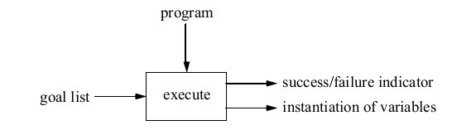

The meaning of the two output results is as follows:

a) The success/failure indicator is 'yes' if the goals are satisfiable and 'no' otherwise. 'yes' signals a successful termination and 'no' a failure .

b) An instantiation of variables is only produced in the case of a successful termination; in the case of failure there is no instantiation.

To execute a list of goals G1, G2, ..., Gm the procedure execute uses the search strategy depth-first with backtracking. That is, it proves the goals in the order in which they appear, propagating variable bindings as they are determined during unification, and backtracking when a certain goal proof fails, in order to try another proof.

5) Recursion in Prolog

Recursion is a technique that is commonly used in prolog and other AI languages. It is a method in which a function calls itself.

Example

Look at the ancestor rule. It could be defined using several clauses especially for a deep linkage. This may be difficult. The problem is overcome by including the ancestor rule which calls itself.

For each X, Z,

X is an ancestor of Z if there is a Y such that

X is parent of Y and
Y is ancestor of Z.

In prolog this is written as:

ancestor(X,Z):- parent(X,Y), ancestor(Y,Z).

6) Data objects

Syntactically, all data objects in Prolog are terms i.e. a constant, a variable, or a function the arguments of which are terms. The following diagram summarizes data objects in Prolog

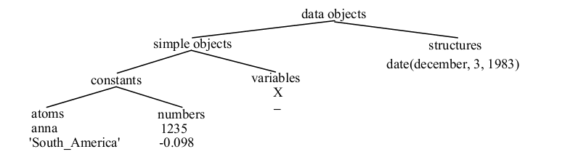
i). Variables

Variables are strings of letters, digits and underscore characters. They start with an upper-case letter or an underscore character.

haschild(X) :- parent(X, Y). % X has a child if there is Y such that X is the parent of Y

Each time a single underscore character occurs in a clause it represents a new anonymous variable.

haschild(X) :- parent(X, _). % X has a child if X is the parent of someone

If the anonymous variable appears in a question clause then its value is not output when Prolog answer the question:

?- parent(X, _). % Who is a parent ? or

X = pam; % Find X such that X is a parent of someone.

X = tom;

X = bob;

X = pat

ii). Structures

Structured objects (structures) are objects that have several components. The components themselves can, in turn, be structures.

A structured object corresponds to a function (or functional term) in logic.

Example: date(december, 3, 1983)

All structured objects in Prolog are trees, represented in the program by terms.

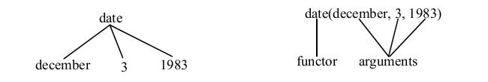

P1 = point(1,1), P2 = point(2,3), segment(P1, P2)= segment(point(1,1), point(2,3))

T = triangle(point(4,2), point(6,4), point(7,1)).

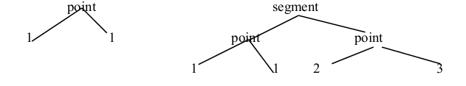

It should be noted that the functions of Prolog are seen as compound data structures similar to the records of Pascal: they can be constructed and analyzed. They are not functions applied to arguments to denote the corresponding result.

iii).Lists

A list is any sequence of a number of items. Generally, it is a data structure that is either empty or consists of two parts: a head and a tail. The tail itself has to be a list. The empty list is represented as [].

A list with Head and Tail is represented as .( Head, Tail)

Lists are handled in Prolog as a special case of binary trees.

For improved readability Prolog provides a special notation for lists:

[ Item1, Item2, ...]

or [ Head | Tail]

or [ Item1, Item2, ... | Others]

Example:

The following is representation of lists

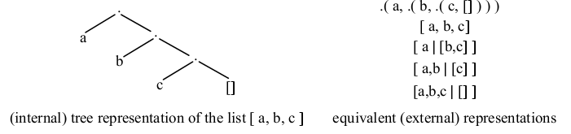
Operations on Lists

i). Membership

This is used to check if an element is in a list. You require to define the relation member(X, L), where X is an object and L is a list.

X is a member of L if either

X is the head of L, or

X is a member of the tail of L.

Run the program

member( X, [X | Tail] ).

member( X, [Head | Tail] ) :- member( X, Tail).

ii). Concatenation
We define the relation conc( L1, L2, L3) where L1 and L2 are two lists and L3 is their concatenation. conc corresponds to append in LISP.

conc( [], L, L). % the concatenation of an empty list [] with a list L is L

conc([X | L1], L2, [X | L3] ) :- % a non-empty list has the form [X | L1]

conc( L1, L2, L3). % the concatenation of [X | L1] with a list L2 is

% the list [X | L3],where L3 is the concatenation of L1 and L2

This program can be used for concatenating given lists:

?- conc([a,b,c], [1,2,3], L).

L = [a,b,c,1,2,3]

conc could also be used in the inverse direction for decomposing a given list into two lists:

?- conc(U, V, [a,b,c]).

U = []

V = [a,b,c];

U = [a]

V = [b,c];

U = [a,b]

V = [c];

U = [a,b,c]

V = [];

no

iii).Add

Adding an item X to the beginning of a list L can be programmed as a relation

add( X, L, [X | L] ). % X is added in the front of the list

iv). Delete

Deleting an item X from a list L can be programmed as a relation

del ( X, L, L1)

where L1 is equal to the list L with the item X removed.

del( X, [X | Tail], Tail). % if X is the head of the list then the result of deletion of X

% is the tail of the list.

del( X, [Y | Tail], [Y | Tail1]) :- % if X is in the tail, then it should be deleted from there.

del( X, Tail, Tail1)

v). Sublist

sublist( S, L) :- % S is a sublist of L if

conc( L1, L2, L), % L is composed of two lists, L1 and L2, and

conc( S, L3, L2). % L2 is composed of S and some L3.

Built-in Prolog predicates for list handling

• length(List, Length). Determines the length of the list given in the first argument.

Eg. length([we,are,all,fine], Length). Will give Length =4.

• Sort(List, SortedList). Sorts the list in ascending order or alphabetical order.

Eg. sort(([we,are,all,fine], SortedList). Will give SortedList = [all,are,fine,we].

• Append(MainList, SubList, ResultingList). Will add Sublist to Mainlist and present it as Resultinglist.

Eg. append([2,2,2,4], [1,1,3],AppendedList). Will give AppendedList = [2,2,2,4,1,1,3].

• member(SingleItem, ListOfItems). Tests whether single item is one the list items.

Example: member(all,[all,are,fine,we]). Will give: yes

member(all,[2,2,2,2]) . Will give: no.

7) Arithmetic

Prolog is a language that was designed for symbolic manipulation not for computation. Sometimes, however, there is need for computation. Prolog therefore minimally supports arithmetic.

Evaluation of an arithmetic expression is forced by the procedure is and by comparison predicates.

The left argument of the is operator is a simple object. The right argument is an arithmetic expression composed of arithmetic operators (+, -, *, /, mod), numbers and variables.

All the variables in the expression must already be instantiated to numbers at the time of execution of this goal.

?- X is 5 - 2 + 3

6

The comparison operators are >, <, >=, =<, =:= (equality), =/= (non equality)

?- 277 * 37 > 1000.

yes

8) Input and Output

At any time during the execution of a Prolog program, only two files are active: one for input and one for output. These two files are called the current input stream and the current output stream. At the beginning of the execution these two streams correspond to the user's terminal.

The following are some of the built-in input/output functions.

• see(Filename) % Filename becomes the current input stream.

• tell(Filename) % Filename becomes the current output stream.

• seen % closes the current input file.

• told % closes the current output file.

• read(X) % read the term T from the current input stream and match it with X

% If X is a variable then, as a result, X will become instantiated to T.

• write(X) % output the term X on the current output file.

• tab(N) % causes N spaces to be output

• nl % causes the start of a new line at the output.

9) Controlling backtracking

There is a special predicate "!" called cut, which allows you to tell Prolog which previous choices it need not consider again when it backtracks through the chain of satisfied goals. It is generally used to prevent backtracking past it. There are two reasons why it may be important to do this:

• Your program will operate faster because it will not waste time attempting to satisfy goals that you can tell beforehand will never contribute to a solution;

• Your program may occupy less of the computer's memory space because more economical use of memory can be made if backtracking points do not have to be recorded for later examination.

As a goal, "!" succeeds immediately and cannot be resatisfied.

The following is the meaning of the cut mechanism: Let us call the 'parent goal' the goal that matched the head of the clause containing the cut. When the cut is encountered as a goal it succeeds immediately, but it commits the system to all choices made between the time the 'parent goal' was invoked and the time the cut was encountered. All the remaining alternatives between the parent goal and the cut are discarded.

Consider, for instance, the clause of the form:

H :- B1, B2, ..., Bm, !, ..., Bn.

Let us assume that this clause was invoked by a goal G that matched H. Then G is the parent goal. At the moment that the cut is encountered, the system has already found some solution of the goals B1, ..., Bm. When the cut is executed, this (current) solution of B1, ..., Bm becomes frozen and all possible remaining alternatives
are discarded. Also, the goal G now becomes committed to this clause: any attempt to match G with the head of another clause is barred.

Example

Let max( X, Y, Max) be a procedure for finding the maximum of two numbers.

It could be defined as follows:

max(X, Y, X) :- X >= Y. % if X >=Y then max is X

max( X, Y, Y) :- X<Y. % if X<Y then max is Y

The two rules are mutually exclusive. If the first one succeeds then the second one will fail. If the first one fails then the second one succeeds.

Therefore, a more economical formulation with 'otherwise' is possible:

If X >= Y then Max = X

otherwise Max = Y

This is written in Prolog using a cut as:

max( X, Y, X) :- X >= Y, !. % if X >=Y then max is X and

% no other solution is looked for

max( X, Y, Y). % otherwise the max is Y and no comparisson is necessary.

10) Negations

Negation is achieved by using a unary predicate not. It causes failure to succeed even if the fact is proved.

Prolog will answer that "not( Goal)" is true if it is not able to prove that Goal is true.

Consider the following query:

?- not(human(mary)).

Prolog will try to prove "human(mary)". If it succeed, then it will answer "no" to the above query. However, if it fails to prove "human(mary)", then it will answer "yes".

?- not(human(mary)). % this means that Prolog succeded to prove "human(mary)"

no

?- not(human(mary)). % this means that Prolog failed to prove "human(mary)"

yes % it does not mean that mary is not a human, it only it means that Prolog

% does not have enough information to prove that mary is a human.

This interpretation of negation is called negation as failure and is based on the closed world assumption.

Note that this is different from the theoretical view of negation in logic.

11) fail and true

• fail is a special goal that always fails, thus forcing the parent goal to fail.

• true is a special goal that always succeeds.

The definition of not can be written in Prolog as:

not( P) :- P, !, fail. % if P is true then not P will fail and, because of cut, no other solution is looked for

not( P) :- true. % if P cannot be satisfied the second clause is tried which succeeds.

Note: Many Prolog implementations do not support not. In such case we can define not ourselves.

